**ATAR HUMAN BIOLOGY UNIT 3**

**TASK 2 – Endocrine and Nervous System Test**

**NAME: _______________________ WEIGHTING: 5 %**

**DATE: _______________________ MARK: __ / = _____ %**

There are TWO sections in this test, Multiple Choice and Short Answer.

This is a closed book assessment (no notes are allowed).

The time allowed to complete the test is 55 minutes.

Write your answers to the Multiple Choice section on the separate answer sheet provided.

Write your answers to the Short Answer section in space provided.

|  |  |  |
| --- | --- | --- |
|  | **Marks Allocation** | **Your Total** |
| **Multiple Choice** | 9 |  |
| **Short Answer** | 45 |  |
| **Long Answer** | 6 |  |
| **TOTAL** | 60 |  |

**ATAR HUMAN BIOLOGY - Unit 3**

**TEST: Hormones & Nervous System**

Name: _____________________________

**Multiple Choice Answer Sheet**

**Use a ball point or ink pen to mark an X** on the letter that represents the best answer from the choice of answers . Marks are not deducted for wrong answers.

1. A B C D 2. A B C D

3. A B C D 4. A B C D

5. A B C D 6. A B C D

7. A B C D 8. A B C D

9. A B C D

**MULTIPLE CHOICE SECTION (9 MARKS)**

1. The grey matter of the brain is associated with the cerebral cortex. However, it is also found in other locations including:
   1. wherever there are fissures.
   2. the entire surface of the central nervous system.
   3. the frontal lobes.
   4. the outer fold of the cerebellum and the centre of the spinal cord.
2. A student completing an examination experienced the following sequence of events:
3. she opened the first page of her examination
4. she panicked and her heart rate began to increase rapidly
5. she began to write down her first answers
6. she relaxed and her heart rate decreased back to normal levels

Which of the following correctly links the events above to the branches of the nervous system that control them?

|  |  |  |  |  |
| --- | --- | --- | --- | --- |
|  | **(i)** | **(ii)** | **(iii)** | **(iv)** |
| a) | Somatic | Parasympathetic | Somatic | Sympathetic |
| b) | Somatic | Sympathetic | Somatic | Parasympathetic |
| c) | Sympathetic | Somatic | Parasympathetic | Somatic |
| d) | parasympathetic | somatic | sympathetic | somatic |

1. Question 3 refers to the experiment described below:

Calcitonin and parathyroid hormone are hormones involved in the regulation of blood levels in some animals. The results of an experiment to determine the nature of this regulation are presented in Table 1 below. At time 0, Group 1 animals were injected with calcitonin and Group 2 animals were injected with an equivalent amount of parathyroid hormone. Blood samples were taken to determine blood calcium level during the next 24 hours.

|  |  |  |  |
| --- | --- | --- | --- |
| Time (hours) | BLOOD CALCIUM LEVEL (mg/100 mL of blood) | | |
| Group 1 | Group 2 | Control Group |
| 0 | 10 | 10 | 10 |
| 1 | 8 | 12 | 10 |
| 2 | 6 | 14 | 10 |
| 4 | 5 | 13 | 10 |
| 8 | 3 | 10 | 10 |
| 24 | 1 | 10 | 10 |

Which of the following statements is a **CORRECT** interpretation of the data?

1. Parathyroid hormone lowers blood calcium levels.
2. Blood samples were taken from the animals every hour.
3. The effect of the injection of calcitonin was longer lasting than the effect of the injection of parathyroid hormone.
4. The control animals would have been injected with both calcitonin and parathyroid hormone.

Question 4 refer to the diagram below that represents a nerve impulse moving along the axon of a neuron.

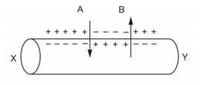

4. If the action labeled “A” in the diagram represents ions entering the neuron, which of the following statements about “A” would be true?

1. Repolarisation and nerve impulse moving from X to Y.
2. Depolarisation and nerve impulse moving from Y to X.
3. Hyperpolarisation and nerve impulse moving from Y to X.
4. Depolarisation and nerve impulse moving from X to Y.

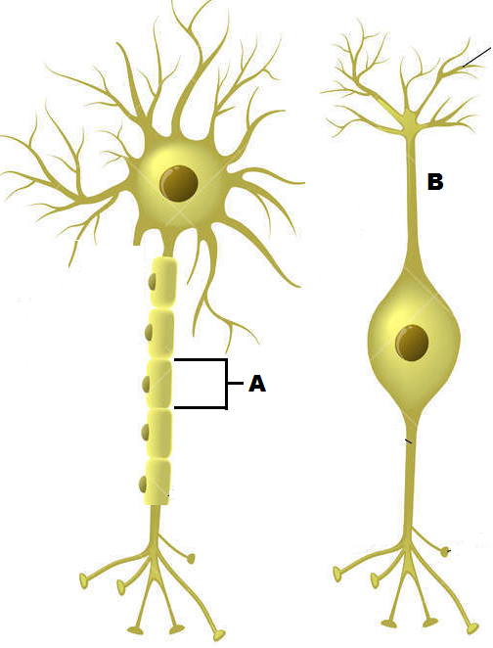The next question refers to the diagram below

5. The cell labeled A has the following function.

* 1. Forms the myelin sheath.
  2. Provides a conducting surface.
  3. Secretes neurotransmitters.
  4. Speeds up hormonal impulses.

**The following information is needed to answer the next TWO questions.**

A patient has complained of the following symptoms to their doctor:

* Feeling a lack of energy
* Unexplained weight gain
* Feeling cold, even though the surrounding temperature is around 25°C.

In response, the doctor had the patient’s Thyroid Stimulating Hormone (TSH) levels tested over five consecutive days. The patient’s results, measured in milli-international units per litre (mIU/L), can be seen in the table below.

|  |  |  |  |  |  |
| --- | --- | --- | --- | --- | --- |
| Day | 1 | 2 | 3 | 4 | 5 |
| TSH concentration (mlU/L) | 2.0 | 2.3 | 2.9 | 2.7 | 2.1 |

A normal range is between 0.4 to 4.0 mIU/L.

6. TSH is a hormone secreted by:

1. the anterior lobe of the pituitary gland and its release is controlled by the thyroid gland.
2. the hypothalamus and released from the anterior lobe of pituitary gland.
3. the posterior lobe of the pituitary gland and its release is controlled by the hypothalamus.
4. the anterior lobe of the pituitary gland and its release is controlled by the hypothalamus.

7. Based on the information the patient provided, the disease the doctor was most likely checking for was:

1. Type 1 diabetes.
2. Type 2 diabetes.
3. Hypothyroidism.
4. Hyperthyroidism.
5. The relative refractory period is caused by:
   1. inactivation of the voltage-gated sodium channels.
   2. inactivation of the voltage-gated potassium channels.
   3. hyperpolarisation due to the opening of the potassium channels.
   4. opening of the voltage-gated potassium and sodium channels.
6. Synthetic hormones differ from natural hormones in all of the following ways except that they:
   1. are chemically altered to form a different shape from their natural hormone.
   2. act identically to the natural hormone they mimic.
   3. are not metabolised as efficiently in the body.
   4. can cause severe side effects.

**Short answer section (45 Marks)**

**Question 1 (6 marks)**

There are three main types of hormones found in the human body protein, amine and steroid hormones. These types of hormones act in two different ways to achieve a response inside a cell.

a) Use the outline below to draw an annotated diagram of the mode of action of a steroid hormone. (4 marks)

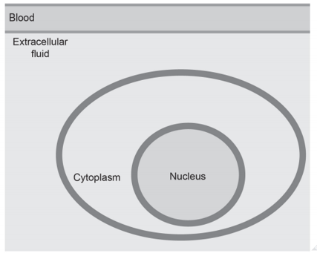

b) Explain why when a person has been given a dosage of adrenaline, giving them another dosage straight away will have little to no effect. (2 marks)

____________________________________________________________________________________________________________________________________________________________________________________________________________________________________________________________________________________________________________________________

**Question 2 (15 marks)**

1. The pituitary gland is sometimes referred to as the “master gland”, however, it could be argued the hypothalamus should have this title. Describe how the hypothalamus controls the secretion of hormones from the anterior and posterior lobe of the pituitary gland. (4 marks)

______________________________________________________________________________________________________________________________________________________________________________________________________________________________________________________________________________________________________________________________________________________________________________________________________________________________________________________________________________________________________________________________________________________________________________________________________________________________________________________________________________________________________________________________________________________________________________________________________________________

b) When the endocrine system goes wrong synthetic hormones can be used to control or treat endocrine dysfunction and improve the quality of life for individuals.

The synthetic hormone insulin is used to treat Type I diabetes. Discuss why this is a suitable treatment for Type I diabetes but not generally for Type II. (4 marks)

_______________________________________________________________________________________________________________________________________________________________________________________________________________________________________________________________________________________________________________________________________________________________________________________________________________________________________________________________________________________________________________________________________________________________________________________________________________________________________________________________________________________________________________________________________

c) Alzheimer’s disease is a neurodegenerative disease that is associated with a dysfunctional autonomic nervous system. Describe what is happening in the brain for a person to develop Alzheimer’s disease. (3 marks)

_________________________________________________________________________________________________________________________________________________________________________________________________________________________________________________________________________________________________________________________________________________________________________________________________________________________________________________________________________________________________________________________________________________________________________

d) Synthetic hormones are used to replace what is not being produced but they are needed to be administered continually. Treatment such as gene therapy and stem cell replacement therapy provide an alternative treatment that can have more lasting effects.

Parkinson’s and Alzheimer’s are two diseases that have benefitted from these treatments. Explain which treatment would be most beneficial to a sufferer of Alzheimer’s disease, including the reasons why it would be the preferred choice. (4 marks)

_______________________________________________________________________________________________________________________________________________________________________________________________________________________________________________________________________________________________________________________________________________________________________________________________________________________________________________________________________________________________________________________________________________________________________________________________________________________________________________________________________________________________________________________________________

**Question 3 (14 marks)**

* 1. Hyperventilation can occur voluntarily or involuntarily. It can occur involuntarily in response to severe pain or extreme fear.

Complete the following table to distinguish between the two different **efferent** nervous divisions that can regulate hyperventilation. (3 marks)

|  |  |  |
| --- | --- | --- |
|  | Names of two different nervous efferent divisions | |
| 1.______________________ | 2. _____________________ |
| Neurotransmitters |  |  |
| Effect of neurotransmitter on  effector(s) / target organ(s) |  |  |

1. The nervous system is also involved in homeostasis. Describe two differences in the way the nervous system controls homeostasis compared to the endocrine system. (2 marks)

______________________________________________________________________________________________________________________________________________________________ _______________________________________________________________________________

1. Negative feedback mechanisms are there to protect the body from harm. The brain has an additional mechanism that protects it from damage, the meninges. (4 marks)

Discuss how the meninges protects the brain from damage, including a description of the structure of the meninges.

________________________________________________________________________________________________________________________________________________________________________________________________________________________________________________________________________________________________________________________________________________________________________________________________________________________________________________________________________________________________________________________________________________________________________________________________________________________________________________________

1. Label the part of the reflex arc shown below. (3 marks)

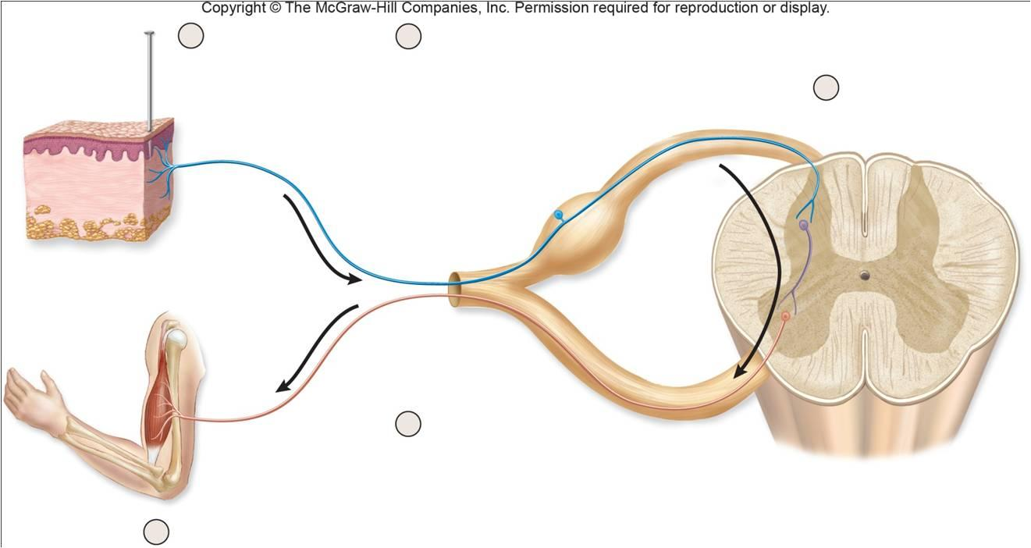

1. Explain why the neural pathways of reflex arcs have very few synapses. (2 marks)

_______________________________________________________________________________

_____________________________________________________________________________________________________________________________________________________________________________________________________________________________________________

**Question 4 (10 marks)**

Below is an action potential graph, showing the outcome from two different stimuli on the same neuron. Look at the graph below and use it to answer the questions that follow.

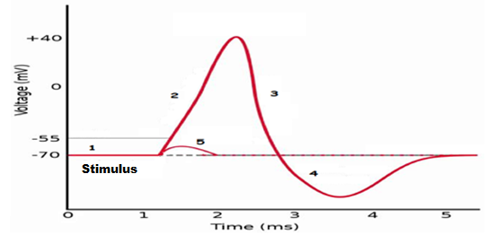

1. The first stimulus resulted in the line labelled with the number 5. Describe what could have occurred here. (1 mark)

______________________________________________________________________________________________________________________________________________________________

1. The second stimulus resulted in the line labelled with the numbers 2, 3 and 4.

Describe TWO events that could not possibly occur during the phases shown by the sections labelled 2, 3 and 4. (2 marks)

____________________________________________________________________________________________________________________________________________________________________________________________________________________________________________________________________________________________________________________________

1. Looking at the action potential graph, locate the section labelled with a 1.

In the box below draw a labelled diagram of this section of the neuron to show: (3 marks)

1. the concentration of the sodium and potassium ions and, if they are moving, the direction

the ions would be travelling.

1. the gated ion channels and whether they are open or closed.
2. the charge either side of the neuron membrane.
3. Look at the diagram below of the different nerve fibres and answer the questions that follow.

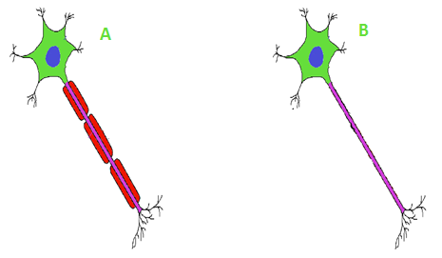

State which of the nerve fibres above would conduct an impulse faster and briefly explain how the impulse will travel along that fibre. (4 marks)

________________________________________________________________________________________________________________________________________________________________________________________________________________________________________________________________________________________________________________________________________________________________________________________________________________________________________________________________________________________________________________________________________________________________________________________________________________________________________________________

**Extended Answer. (6 marks)**

Fred was walking home after watching the basketball game through the park. Suddenly the lights went out and Fred could not see a thing. Then he heard footsteps approaching very quickly from behind.

Discuss three nervous system responses that would occur in Fred’s body when he heard the footsteps approaching that would enable him to run home quickly and the different nervous system responses that would occur when he was safe at home.

______________________________________________________________________________________________________________________________________________________________________________________________________________________________________________________________________________________________________________________________________________________________________________________________________________________________________________________________________________________________________________________________________________________________________________________________________________________________________________________________________________________________________________________________________________________________________________________________________________________________________________________________________________________________________________________________________________________________________________________________________________________________________________________________________________________________________________________________________________________________________________________________________________________________________